ANANYA PANT , SAP ID-590021797

1 OCTOBER – LAB CLASS WORK

Q1 – Write a program to check Whether Two Strings are Anagrams or not

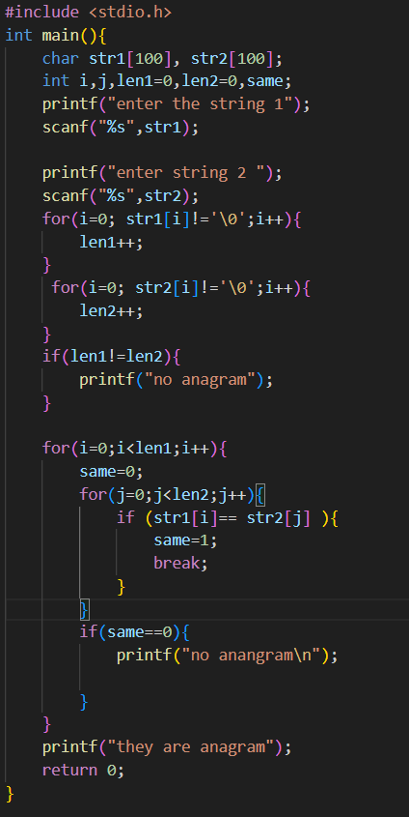

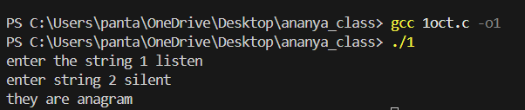

Q2-Write a program to find sum of digits using recursion.

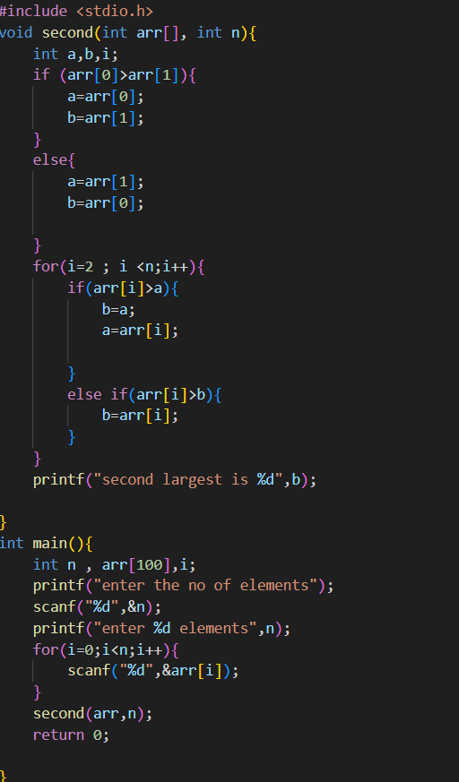

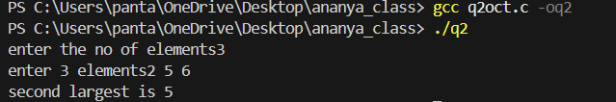

Q3-Write a program to find sum of digits using recursion.

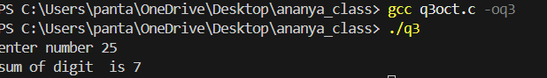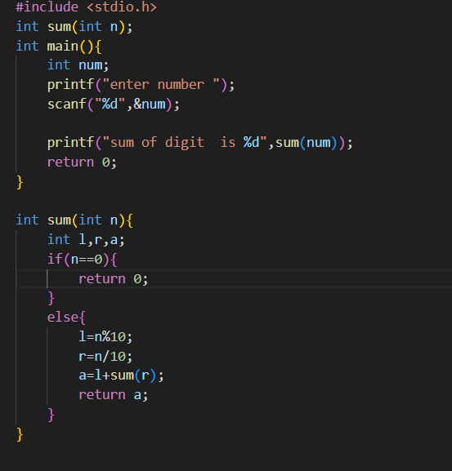

Q4-Write a program and a function to swap two numbers using call by reference.

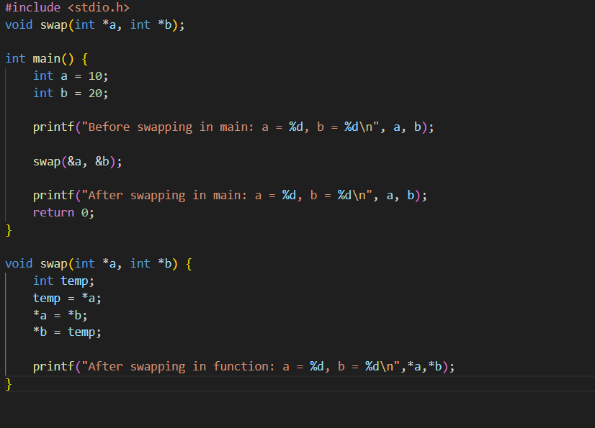

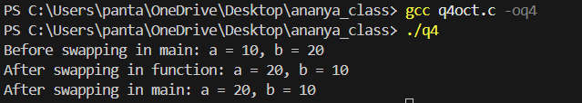

Q5 Write a function to sort an array using functions.

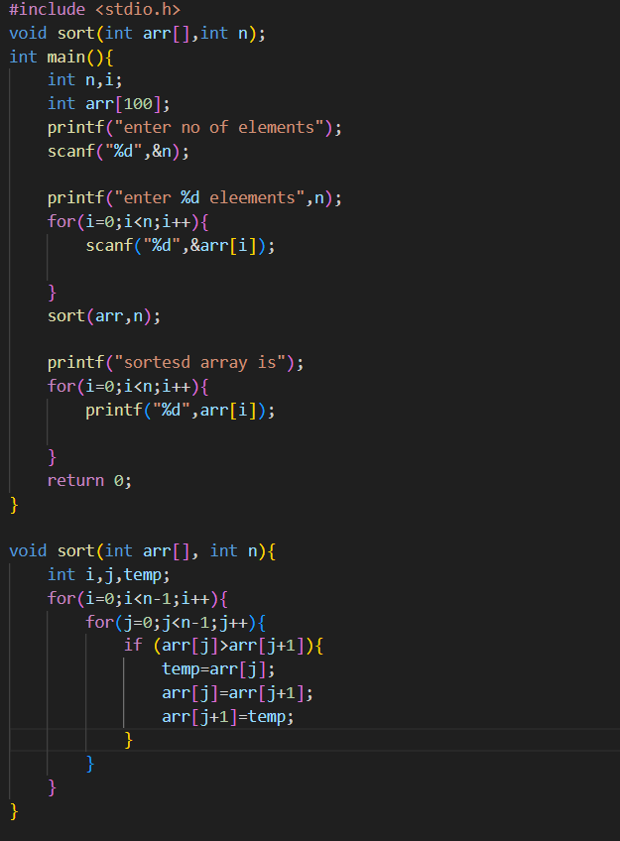

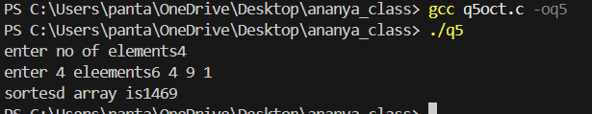

Q6 Write a program to define a structure name student with roll number, name, and marks.

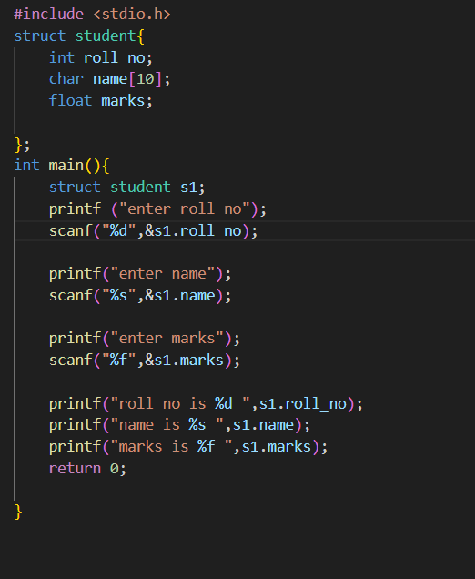Write functions to input and display student details.

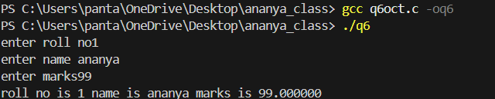

Q7- Write a program to create a structure employee (ID, Name, Basic Pay, DA, HRA, Gross Salary).

and write a function to calculate salary and display details.

